TO: Professor Linninger
FROM: Melika Salehabadi
DATE: July 30, 2019
SUBJECT: Weekly Report

Abstract
I have finished the MATLAB code for transferring a known cross section from the first end point of a Bezier curve, up to the middle point. The cross at the first end point is perpendicular to a previously defined ez coordinate axis. As the coordinate system sweeps along the curve, the cross-section normal axis gradually becomes tangent to the centerline curve. The cross-section normal axis becomes completely tangent to the center-line curve at a given tcutoff point. The code is written by reformatting the Delphi code I had into MATLAB, with some modifications.

Results
The most important part of my MATLAB code and the generated plots are explained in this section. The code below was used to generate surface mesh cross sections from t=0 to t=0.5, with tcutoff=0.3.

function transGeom = SurfMesh(t1,t2,NSegments,e1,e2,e3,crossSection,splineCtrlPts)

dt=(t2-t1)/NSegments;
e1 = reshape(e1,[3,1]);
e2 = reshape(e2,[3,1]);
e3 = reshape(e3,[3,1]);
e11=e1;
e12=e2;
e13=e3;
tcutoff=0.3;
saveCrossSection{1}=crossSection;
tt=t1:dt:t2;
ppi(:,1)=splineCtrlPts(:,1);
A=crossSection;
for i=2:NSegments
ppi(:,i)=BezierSpline(tt(i),splineCtrlPts);
vi=BezierTangent(tt(i),splineCtrlPts);
alfa=(tt(i)/tcutoff)*(tt(i)<tcutoff)+(1-tt(i))/tcutoff*(tt(i)>(1-tcutoff))+1*(tt(i)>tcutoff&tt(i)<(1-tcutoff));
nn1 = e13*(1-alfa)+alfa*vi;
aaProj = dot(nn1,e11)*normalize(nn1);
e1i = normalize(e11-aaProj);
e3i = normalize(nn1);
e2i = normalize(cross(e3i,e1i));
JJ = [e1i,e2i,e3i];
R = JJ/[e11,e12,e13];
A = transferAndRotate(A,R,ppi(:,i-1),ppi(:,i));
saveCrossSection{i+1} = A;
e11 = e1i;
e12 = e2i;
e13 = e3i;
end
transGeom=saveCrossSection; end

function newCrossSection = transferAndRotate(crossSection,J,ppi1,ppi2)
crossSection = reshape(crossSection,3,[]);
newCrossSection = zeros(size(crossSection));
for i = 1:size(crossSection,2)
newCrossSection(:,i) = J*(crossSection(:,i)-ppi1)+ppi2;
end
end

Fig. 1 and Fig. 2 show the resulting curves generated by the MATLAB code above in different views.

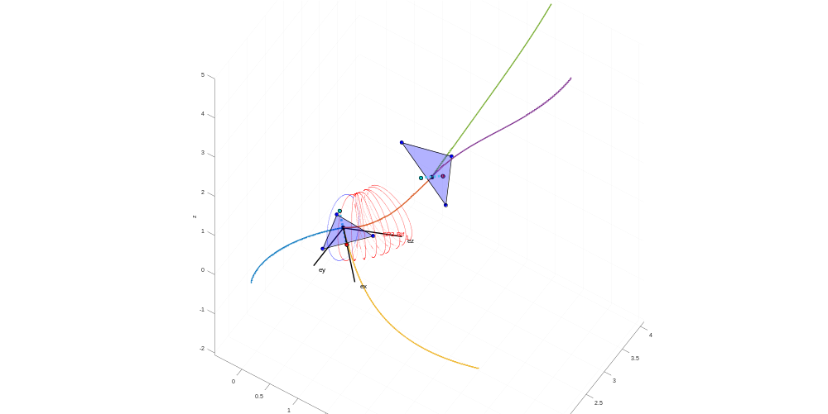
Figure 1: cross sections from t=0 to t=0.5

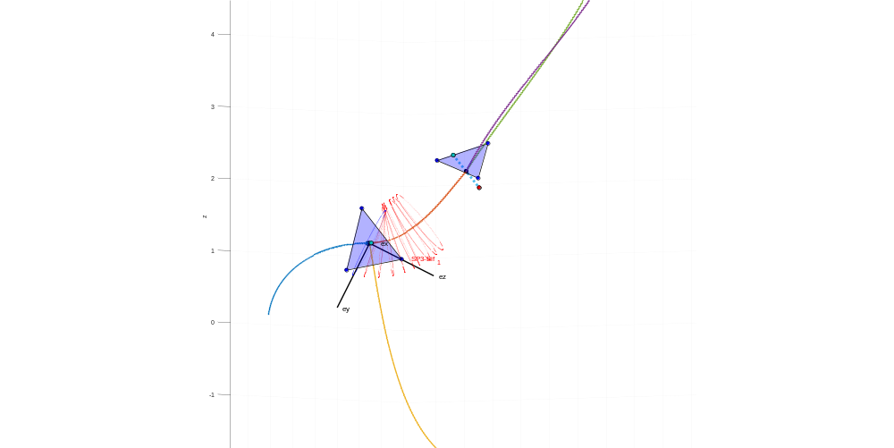
Figure 2: cross sections from t=0 to t=0.5 in different view

Conclusions
I wrote a MATLAB program to generate the surface mesh cross sections from t=0 to t=0.5 for a given initial cross section at the first end point. The results show that the angle between the cross section and the Bezier tangent vector will gradually decrease from t=0 to t=tcutoff. Then, from tcutoff=0.3 to t=0.5 the cross-section plane is perpendicular to the center line of the tube.

Future Work
- I am documenting reformatting the part of the Delphi code that I have completed so far for future reference.
- I will work on the next part of the Delphi code.

